COUNTY OF MORRIS
DEPARTMENT OF HUMAN SERVICES

Board of County Commissioners
Commissioner Director
Tayfun Selen

Deputy Commissioner Director
John Krickus

Douglas R. Cabana
Kathryn A. DeFillippo
Thomas J. Mastrangelo
Stephen H. Shaw
Deborah Smith

County Administrator
John Bonanni

Department Director
Katharine A. Errico
973-285-6863

Deputy Director
Gary L. Denamen
973-326-7240

P.O. Box 900
Morristown, New Jersey 07963-0900

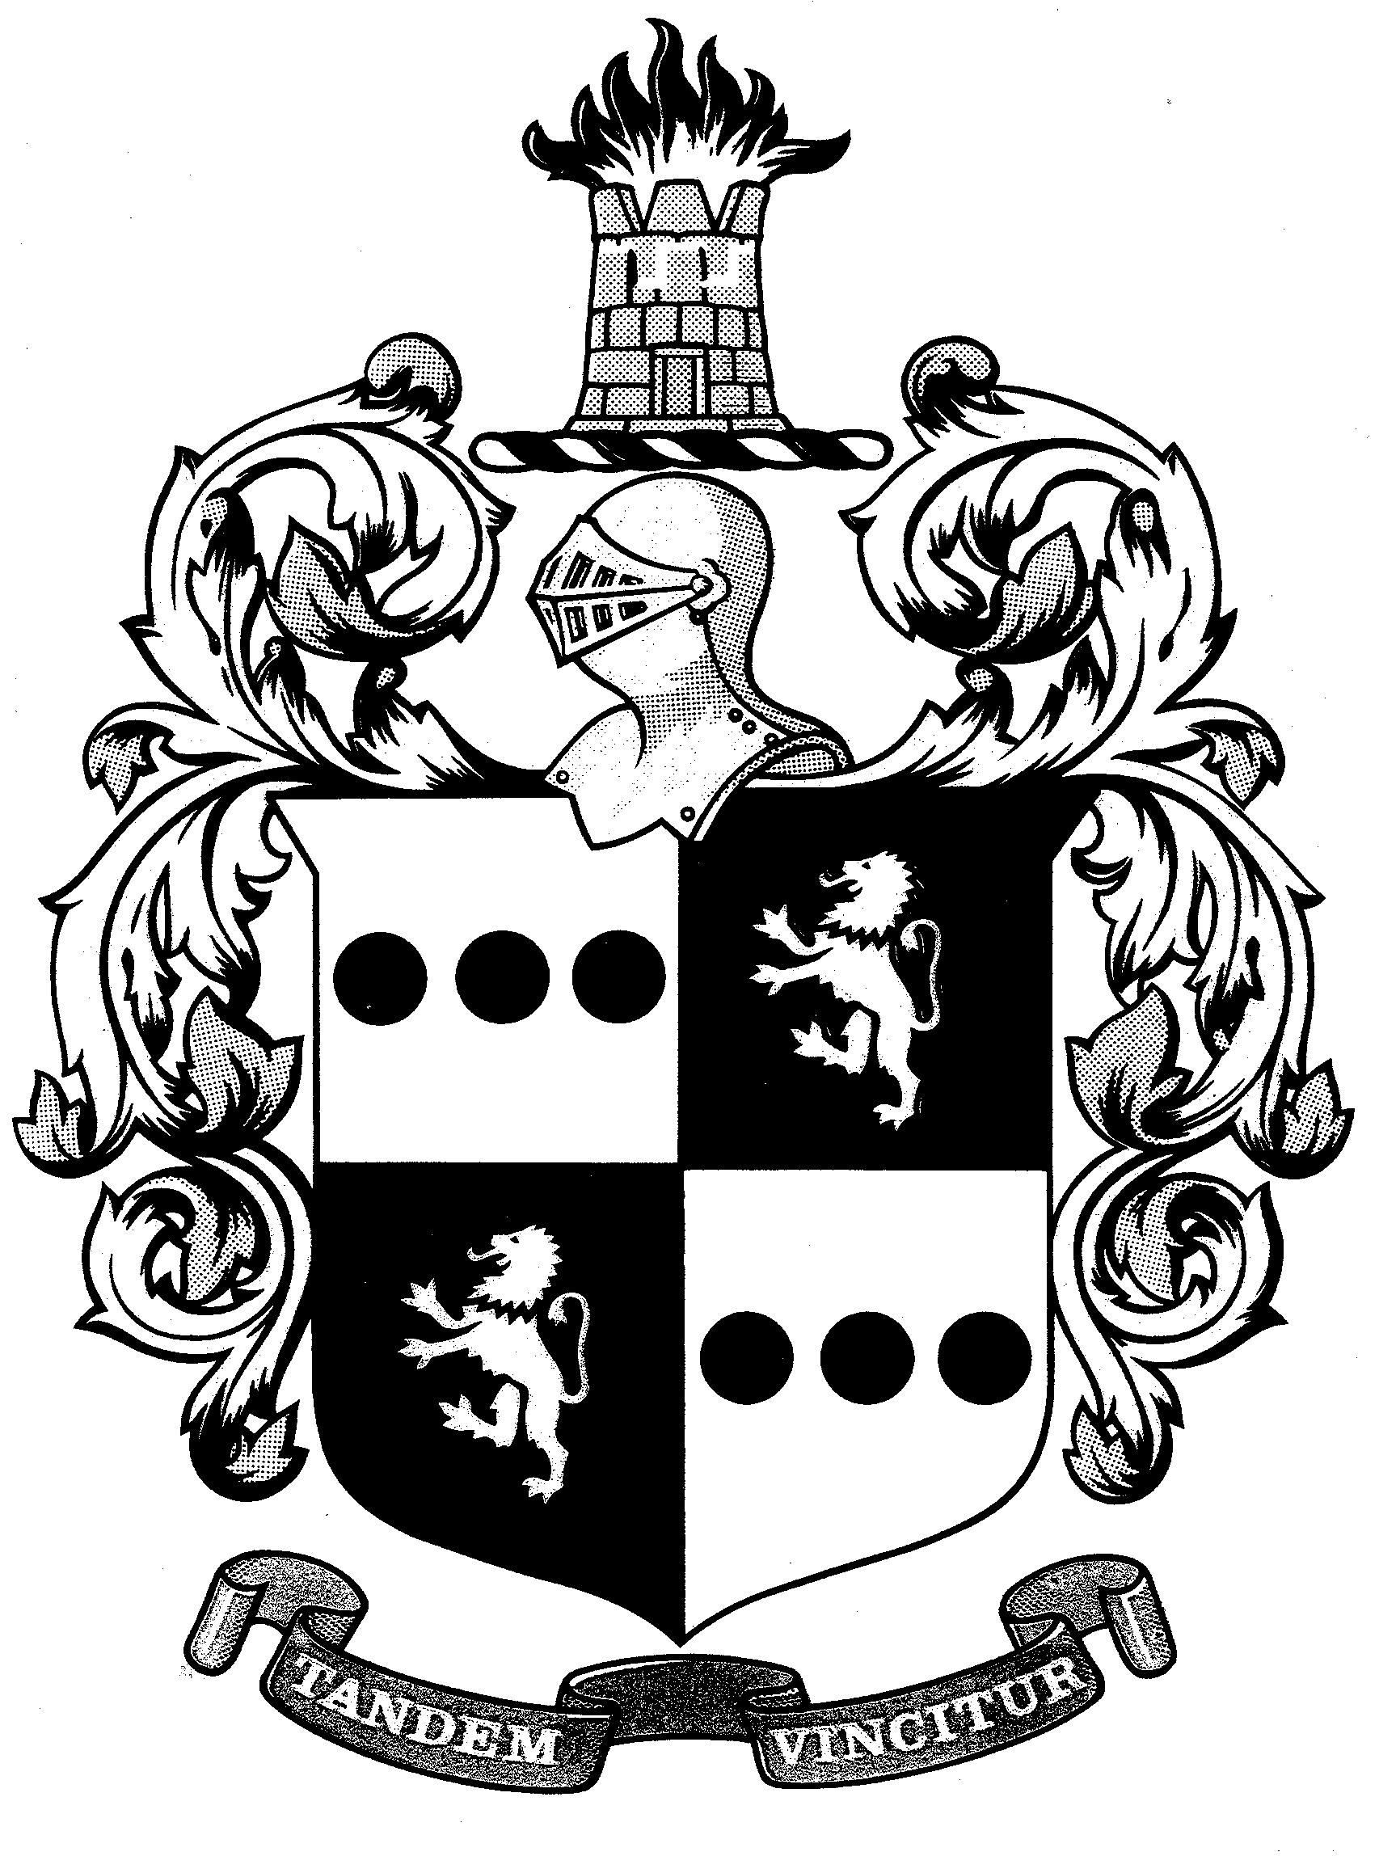

MEMORANDUM

To: Interested Service Providers

From: Katharine Errico, Director, Department of Human Services

Date: July 18, 2022

Re: Invitation to Submit Applications—2023 CY Funding

Please be advised that funding applications are available through the Morris County Department of Human Services. Anticipated 2023 funding is intended for the provision of services identified within Morris County planning documents. All funding is subject to budget availability and at the discretion of the Morris County Board of County Commissioners.

A Request for Funding Application (RFA) must be submitted to be considered for 2023 funding for the following:

- Child Abuse Prevention (CAP) – County funding to support child abuse prevention programs for at-risk families in crisis with the goal of strengthening the family unit.

- Social Services for the Homeless (SSH) - State funding for short-term assistance for individuals and families at-risk of homelessness. Services include emergency shelter/hotel/motel placement, prevention of homelessness activities (rental subsidies, security deposits, rent/mortgage/utility assistance) and/or case management services for homeless individuals and families.
- Grant-in-Aid – County funding for the areas of Mental Health, Substance Use, Aging, Veterans, Disabilities, Youth Services and General Human Services:
  - Youth Services – Community-based and child/family centered services for children and youth with social/emotional needs who are at risk of out of home placement.
  - Mental Health/Substance Use –Client-centered, trauma-informed, wellness and recovery services for those in need of mental health and/or substance use services.
  - General Human Services –Support for individuals and families facing economic deprivation, housing crisis, and/or family management services.
  - Aging, Disabilities, and Veteran Services - Community-based services to seniors age 60 or older, Caregivers of Seniors, Adults age 18 or older with a disability, Caregivers of individuals with disabilities, and/ or Veterans.

- Chapter 51 – State funding for substance use for education and prevention, treatment, recovery, treatment and prevention, recovery supports, and detox services for those who lack financial means to access treatment due to lack of insurance or the ability to self-pay.

- Juvenile Justice Funding (State Community Partnership, Family Court, Core Services) – State funding for community-based services for at-risk juveniles ages 7 - 21 to prevent juvenile delinquency, provide diversion from the Juvenile Justice System, or provide dispositional options for court involved youth.

- Navigating Hope – County funding for care management for operations and staffing for mobile outreach services

The RFA application package for the above funding sources is now available and can be accessed online at https://www.morriscountynj.gov/Departments/Community-Behavioral-Health-Services/Funding. The package contains detailed information regarding the application process, including funding priority summaries, and instructions for completing the RFA.

All agencies must submit one (1) signed original and one (1) copy of the completed application and any supporting documentation.

Application Due Date: Applications are due by 2:00 p.m. Thursday, July 28, 2022.
**Applications must be received by 2:00 p.m. on the due date. No exceptions. Late applications will be returned unopened**

By mail: In-person or FedEx: Drop box will be located at the
entrance of the Morris County Human Services building
Morris County Dept. of Human Services Morris County Dept. of Human Services
PO Box 900 1 Medical Drive
Morristown, NJ 07963-0900 Morris Plains, NJ 07950
Attn: Anna Marie Hess Attn: Anna Marie Hess

Please be reminded:
- All funding is subject to budget availability and at the discretion of the Morris County Board of County Commissioners.
- This public funding may only be billed for a specific unit of service when there is no third-party insurance, Medicare, Medicaid or any other type of reimbursement, in whole or in part, for that service unit.

If you require further information or assistance with the RFA process, contact:

Aging, Disabilities and Community Programming: Maria Rosario at 973-285-6847
Community and Behavioral Health Services: Anna Marie Hess at 973-285-6853

Thank you for your interest in serving Morris County residents.

cc: John Bonanni, County Administrator
Deena Leary, Assistant County Administrator
Amy Archer, Division Director, Community & Behavioral Health Services
Christine Hellyer, Division Director, Aging, Disabilities and Community Programming

