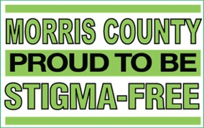

STIGMA‐FREE COMMUNITIES INITIATIVE
COLLEGES AND UNIVERSITIES TOOLKIT
WRITTEN IN COLLABORATION WITH COUNTY COLLEGE OF MORRIS

The Morris County Stigma‐Free Communities Initiative is a county‐wide program which aims to eradicate the stigma associated with mental illness
rs.

and substance use disorde

Morris County Department of Human Services
P.O. Box 900 Morristown, NJ 07963‐0900
Laurie Becker, Mental Health Administrator (973) 285‐6852

For further information or an electronic version of this toolkit, please visit: www.morriscountynj.gov/hs/stigma‐free

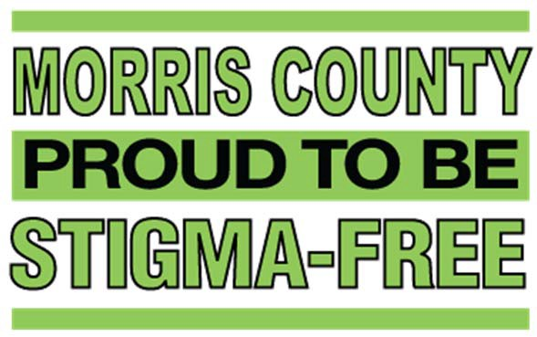

TABLE OF CONTENTS
Introduction……………………………………………………………..………………………………3 Prevalence of Mental Illness………..……………………………………………………………..3 The Stigma‐Free Campaign…………......………………………………………………………….4
Sample Resolution………………………………………………………………………………………5
Stigma‐Free Toolkit…………………………………………………….…………………………….6-9
Forming a Task Force…………………………….…………………………………………6 Stigma Free Action Plan……………..………………………………..……………………7 Mental Health First Aid………………………………………………………….………….8 Sample Press Materials...…………………………………………………………………...9

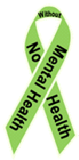
Mental Illness and Stigma

What is a mental illness?
Mental illnesses refer to disorders generally characterized by dysregulation of mood, thought, and/or behavior. Mental illness encompasses a variety of disorders ranging from depression and anxiety to substance
and alcohol use disorder and bipolar disorder. Mental illnesses can affect persons of any age, race, religion or income.

What is stigma?
Stigma is a mark of disgrace which results from the judgment by others. When an individual is labelled by their illness they experience judgment and prejudice.
Stigma brings experiences and feelings of shame, embarrassment, distress, hopelessness and reluctance to seek or accept help. As a result, stigma is the primary reason individuals do not seek help when they experience symptoms of mental illness.

Introduction

The Morris County Stigma‐Free Communities Initiative is a county‐wide program which aims to eradicate the stigma associated with mental illness and substance use disorders. We are dedicated to raising awareness of these illnesses by creating an environment where affected individuals are supported in their efforts to achieve wellness and recovery.

Prevalence of Mental Illness

The World Health Organization ranks mental health conditions, including alcohol and substance use disorders, as the leading cause of disability in the United States and Canada, affecting people of all ages and backgrounds. 1 in 4 adults experience a diagnosable mental disorder in a given year (approximately 61.5 million Americans) and 1 in 17 adults live with a serious mental illness such as schizophrenia or bipolar disorder. Yet more than half will not seek treatment. Why?

The primary reason individuals fail to seek the help they need is due to the stigma associated with the disease of mental illness. Main reasons cited are shame and fear of judgment from friends, family and co‐workers. Such judgment is often rooted in a lack of knowledge or training. It is our goal to disseminate information and foster a stigma‐free environment where people are free from judgment and can get the help they need to recover from disease.
For more information on the disease of mental illness, visit www.nami.org

The Stigma Free Communities Initiative
Stigma‐Free Communities aim to inspire public interest and open dialogues about stigma. The County of Morris and several Morris County towns have already passed Stigma‐Free resolutions.

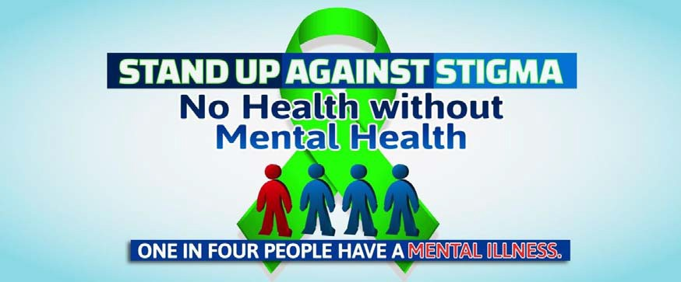

Establishing Stigma‐Free Communities will raise awareness of the local mental health and recovery resources available so that no resident needs to feel hopeless or alone. Stigma‐Free Communities will encourage residents to break down barriers and be mindful of their mental health and ask for help when needed. Substance use disorders and mental illness have the potential to worsen if left untreated and complications arise when individuals do not seek help. It is essential that residents engage in care as soon as the need is identified so recovery can begin, hope is inspired and tragedies are avoided.
Who is involved? Everyone is involved. This county‐wide initiative includes all Morris County residents, young and old. From bus drivers to school administrators, business owners to law enforcement, every community member is a key stakeholder. We want to link all stakeholders to training opportunities and awareness events aimed at increasing public knowledge about mental illness and substance use disorders and knowledge of local resources available to Morris County residents.
The following pages include a Stigma‐Free toolkit for Morris County Colleges and Universities interested in joining the Stigma‐Free Initiative. By joining the Stigma‐Free Initiative your campus will be joining a rapidly growing network of municipalities and institutions dedicated to improving the behavioral health of our Morris County community

SAMPLE Stigma Free College/University Campus Resolution

WHEREAS, the Morris County Board of Chosen Freeholders, along with the Morris County Department of
Human Services, supports the designation of Stigma‐Free College/University Campus, and;

WHEREAS, at their April 27, 2016 meeting the Morris County Board of Chosen Freeholders unanimously passed a resolution supporting the designation of Morris County as a Stigma‐Free Community, and;
WHEREAS, Morris County recognizes that one in four Americans has experienced mental illness, including substance use disorders, in a given year according to the National Institute of Mental Health, and;

WHEREAS, mental health problems are more common than cancer and heart disease combined, affecting children and adults, including more than half of our Iraq and Afghanistan Veterans treated at Veteran's Administration hospitals, and;

WHEREAS, given the serious nature of this public health problem, we must continue to reach the millions who need help;

WHEREAS, the stigma associated with the disease of mental illness is identified as the primary reason individuals fail to seek the help they need to recover from the disease, and;

WHEREAS, Stigma‐Free Campuses aim to inspire public interest and open dialogues about stigma, raise awareness of the disease of mental illness and create a culture wherein students who have the disease of mental illness feel supported by their college community and feel free to seek treatment for the disease without fear of stigma and;

WHEREAS, promoting awareness that there can be no “health” without mental health will break down barriers and encourage students of all ages to be mindful of their mental health and ask for help when needed, and;

WHEREAS, local resources are available to treat the disease of mental illness so no one student needs to suffer alone or feel hopeless, and;

WHEREAS, establishing Stigma‐Free Campuses will raise awareness of resources and encourage students to engage in care as soon as the need is identified so recovery can begin, hope is inspired and tragedies are avoided, and;

NOW THEREFORE BE IT RESOLVED that [XXX College/University] recognizes the campus needs and supports the efforts of the County of Morris in designating [XXX College/University] as a Stigma‐Free Campus

Forming a Stigma‐Free Task Force

Identify Stigma-Free ambassadors
- A Stigma-Free ambassador is any college community member who embraces the Stigma-Free Initiative and will help bring your Stigma-Free Campus to life.
- Stigma-Free ambassadors are involved college community members who are connected to the college community and understand the specific strengths and weaknesses of your campus.
Ambassadors do not have to be mental health professionals; they can be individuals who are passionate, interested and energetic. Any proactive college community member can become a Stigma-Free ambassador. An ambassador could be a student, professor, counselor, coach, or faculty member of any kind. Often times, it could be a person who has personally been affected by a mental illness or substance use disorder, either directly or through a family member.

Form a Stigma-Free task force
Gather a team of dedicated Stigma-Free ambassadors who can help enhance the culture of caring in your community, this will be your Stigma-Free Task Force. You can choose to invite task-force members directly, or begin by holding an interest meeting to inform college community members about the Stigma-Free Initiative, educate and promote awareness, and gather public interest
Who to invite to join the Stigma-Free Task Force:
- Dean/Academic Chair person
- Health Services Coordinator
- Staff or students from department of Psychology/Sociology
- Public Safety/Campus Security
- Campus life/Residence Life
- Counselors/Counseling Center representatives
- Committee chair/co-chair
- Club members- any club on campus
- Athletics Representative
- SGA Representative
- Honors Society
- Educational Opportunity Fund (EOF)
- Board of Trustee

Stigma‐Free Action Plan
Below are some ideas to bring your Stigma-Free Campus to life. Feel free to follow these suggestions and plans and add your own that you think will benefit your campus. Also, keep in mind that you do not have to do all of these tasks. Any steps you take to decrease stigma are steps in the right direction. If you are already hosting similar events on campus, you may include them to the Stigma-Free Initiative by simply rebranding the event as “[Event name]: A Stigma-Free Event” and including the welcome message (detailed on the following page).
- Participate in a college council meeting (i.e. Inter Club Council, Student Government Association)
- Host a stigma free event (i.e. De-stress Fest, Wellness Forum, Stigma-Free Walk, Recovery Concert)
- Set up a Stigma-Free information booth at other campus events (i.e. orientation)
- Promote personal stories of wellness and recovery (i.e. guest speakers, open mic for students)
- Collaborate with local non-profits and recovery groups to support their efforts.
- Offer Mental Health First Aid training for staff and/or students.
- Advocate for inclusion of a Stigma-Free assignment in the curriculum of an art or performing art class.
- Youth outreach through specific programs (i.e. Education or Social Work Majors interning at schools, summer camp on campus)
- Develop a Stigma-Free Website with local mental health resources and information or add a Stigma-Free link to an already existing website.
- Promote Stigma-Free through the student newspaper or a local newspaper (i.e. provide an announcement about the Stigma-Free Initiative or a Stigma-Free Event, provide a monthly Stigma-Free update)
- Distribute Stigma-Free promotional materials (i.e. Lawn signs, decals, pens)

Example Stigma-Free Welcome Message:
“Hello, and welcome to the [insert event name]. In line with our new Stigma-Free Initiative on campus, this event will be a Stigma-Free event. Stigma is a mark of disgrace which results from judgment by others. Stigma brings experiences and feelings of shame, embarrassment, distress, hopelessness and reluctance to seek or accept help. As part of a county-wide initiative, [insert school name here] is acting to disseminate information and foster a stigma-free environment where people are free from judgment and can get the help they need to recover from mental illness and substance use disorders. We’d like to open this event by reminding you that everyone has the power to break through stigma. We encourage you to support one another, seek the services you need, and do not judge. Together we can decrease stigma to create a culture of caring on campus. Please contact [insert contact person] for more information.”

Mental Health First Aid

What is Mental Health First Aid?

Mental Health First Aid is a public education program that introduces participants to risk factors and warning signs of mental health problems, builds understanding of their impact and overviews appropriate supports. This 8‐hour course uses role‐playing and simulations to demonstrate how to offer initial help in a mental health crisis and connect people to the appropriate professional, peer, social and self‐help care. The program also teaches common risk factors and warning signs of specific illnesses like anxiety, depression, substance use, bipolar disorder, eating disorders and schizophrenia.

What do you learn?
Just as CPR helps you assist an individual having a heart attack, Mental Health First Aid helps you assist someone experiencing a mental health or substance use‐related crisis. In the Mental Health First Aid course, you learn risk factors and warning signs for mental health and addiction concerns, strategies for how to help someone in both crisis and non‐crisis situations, and where to turn for help.

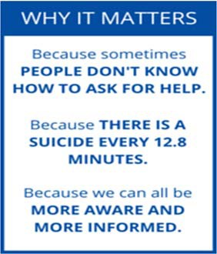

You could be the help that someone needs. Get trained today!
If you are interested in attending a training, hosting a training course for your organization or would like more information visit www.morriscountynj.gov/hs/stigma‐free or contact Laurie Becker, Mental Health Administrator at 973‐285‐6852 or lbecker@co.morris.nj.us

Sample Press Release:
Sample Press Materials

[COLLEGE] DECLARES CAMPUS A STIGMA‐FREE ZONE

One in four adults experiences a diagnosable mental illness every year and many of these individuals do not seek help because of fear of shame or judgment from friends, family and coworkers. On [DATE] [COLLEGE] made the first steps towards eliminating the stigma associated with mental illness. The elimination of mental health stigma will allow residents to get the resources they need without judgment.

[COLLEGE] joins the County of Morris in an initiative to make their campus a Stigma‐Free Zone in order to create an environment in which students will feel free to seek treatment for the disease of mental illness without the fear of being stigmatized.

[COLLEGE] hopes to raise awareness of the disease of mental illness, provide an effective way to
reduce the stigma associated with the disease and encourage those who are affected to seek services and feel supported. The establishment of this Stigma‐Free Zone will raise awareness of local mental health resources so no one student needs to feel hopeless or alone. The elimination of stigma will enable students to ask for help when needed so recovery can begin, hope is inspired and tragedies are avoided.

[COLLEGE] urges anyone who would like more information on the Stigma‐Free Campaign to contact and to help us to eliminate stigma and promote wellness amongst all [COLLEGE] students and Morris County residents.

