STIGMA-FREE COMMUNITIES INITIATIVE
MUNICIPALITY TOOLKIT

The Morris County Stigma-Free Communities Initiative is a county-wide program which aims to eradicate the stigma associated with mental illness and substance use disorders.

Morris County Department of Human Services
P.O. Box 900
Morristown, NJ 07963-0900
Laurie Becker, Mental Health Administrator
(973) 285-6852
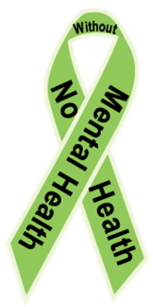

For further information or an electronic version of this toolkit, please visit:
www.morriscountynj.gov/hs/stigma-free

TABLE of CONTENTS

Introduction……………………………………………………………..………………………………3
Prevalence of Mental Illness………..…………………………………………………………….3
The Stigma-Free Campaign…………......…………………………………………………………4
Stigma-Free Toolkit…………………………………………………….…………………………….5-10
Sample Stigma-Free Community Resolution………………………………………5
Forming a Task Force…………………………….…………………………………………6
Stigma Free Action Plan……………..………………………………..……………………7
Mental Health First Aid………………………………………………………….………….8
Sample Press Materials...…………………………………………………………………...9

Mental Illness and Stigma
What is a mental illness?
Mental illnesses refer to disorders generally characterized by dysregulation of mood, thought, and/or behavior. Mental illness encompasses a variety of disorders ranging from depression and anxiety to substance and alcohol use disorder and bipolar disorder. Mental illnesses can affect persons of any age, race, religion or income.

What is stigma?
Stigma is a mark of disgrace which results from the judgment by others. When an individual is labelled by their illness they experience judgment and prejudice. Stigma brings experiences and feelings of shame, embarrassment, distress, hopelessness and reluctance to seek or accept help. As a result, stigma is the primary reason individuals do not seek help when they experience symptoms of mental illness.

Introduction

The Morris County Stigma-Free Communities Initiative is a county-wide program which aims to eradicate the stigma associated with mental illness and substance use disorders. We are dedicated to raising awareness of these illnesses by creating an environment where affected individuals are supported in their efforts to achieve wellness and recovery.

Prevalence of Mental Illness
The World Health Organization ranks mental health conditions, including alcohol and substance use disorders, as the leading cause of disability in the United States and Canada, affecting people of all ages and backgrounds. 1 in 4 adults experience a diagnosable mental disorder in a given year (approximately 61.5 million Americans) and 1 in 17 adults live with a serious mental illness such as schizophrenia or bipolar disorder. Yet more than half will not seek treatment. Why?
The primary reason individuals fail to seek the help they need is due to the stigma associated with the disease of mental illness. Main reasons cited are shame and fear of judgment from friends, family and co-workers. Such judgment is often rooted in a lack of knowledge or training. It is our goal to disseminate information and foster a stigma-free environment where people are free from judgment and can get the help they need to recover from disease.

For more information on the disease of mental illness, visit www.nami.org

The Stigma Free Communities Initiative

Stigma-Free Communities aim to inspire public interest and open dialogues about stigma. The County of Morris and several Morris County towns have already passed Stigma-Free resolutions.

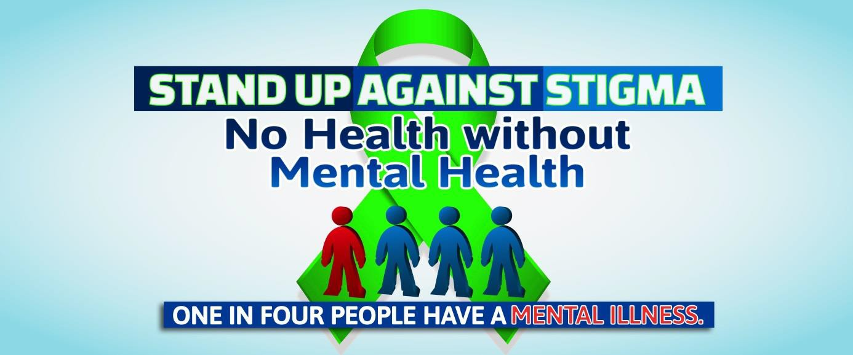

Establishing Stigma-Free Communities will raise awareness of the local mental health and recovery resources available so that no resident needs to feel hopeless or alone. Stigma-Free Communities will encourage residents to break down barriers and be mindful of their mental health and ask for help when needed. Substance use disorders and mental illness have the potential to worsen if left untreated and complications arise when individuals do not seek help. It is essential that residents engage in care as soon as the need is identified so recovery can begin, hope is inspired and tragedies are avoided.
Who is involved? Everyone is involved. This county-wide initiative includes all Morris County residents, young and old. From bus drivers to school administrators, business owners to law enforcement, every community member is a key stakeholder. We want to link all stakeholders to training opportunities and awareness events aimed at increasing public knowledge about mental illness and substance use disorders and knowledge of local resources available to Morris County residents.
The following pages include a Stigma-Free toolkit for Morris County towns interested in joining the Stigma-Free Communities Initiative. By passing a Stigma-Free resolution your town will be joining a rapidly growing network of municipalities dedicated to improving the behavioral health of our Morris County community
SAMPLE Stigma Free Communities Resolution

WHEREAS, the Morris County Board of Chosen Freeholders, along with the Morris County Department of Human Services, supports the designation of Stigma-Free Communities in every municipality, and;

WHEREAS, at their April 27, 2016 meeting the Morris County Board of Chosen Freeholders unanimously passed a resolution supporting the designation of Morris County as a Stigma-Free Community, and;

WHEREAS, Morris County recognizes that one in four Americans has experienced mental illness, including substance use disorders, in a given year according to the National Institute of Mental Health, and;

WHEREAS, mental health problems are more common than cancer and heart disease combined,
affecting children and adults, including more than half of our Iraq and Afghanistan Veterans treated at
Veteran's Administration hospitals, and;

WHEREAS, given the serious nature of this public health problem, we must continue to reach
the millions who need help;

WHEREAS, the stigma associated with the disease of mental illness is identified as the primary reason individuals fail to seek the help they need to recover from the disease, and;

WHEREAS, Stigma-Free Communities aim to inspire public interest and open dialogues about stigma, raise awareness of the disease of mental illness and create a culture wherein residents who have the disease of mental illness feel supported by their community and neighbors and feel free to seek treatment for the disease without fear of stigma and;

WHEREAS, promoting awareness that there can be no “health” without mental health will break down barriers and encourage residents of all ages to be mindful of their mental health and ask for help when needed, and;

WHEREAS, local resources are available to treat the disease of mental illness so no one resident needs to suffer alone or feel hopeless, and;

WHEREAS, establishing Stigma-Free Communities will raise awareness of resources and encourage residents to engage in care as soon as the need is identified so recovery can begin, hope is inspired and tragedies are avoided, and;

NOW THEREFORE BE IT RESOLVED that [TOWN] recognizes the community needs and supports the efforts of the County of Morris in designating [TOWN] as a Stigma-Free Community.
Forming a Stigma-Free Task Force

Identify Stigma-Free ambassadors
- A Stigma-Free ambassador is any resident who embraces the Stigma-Free Initiative and will help bring your Stigma-Free Communities to life.

- Stigma-Free ambassadors are involved community members who are connected to the community and understand the specific strengths and weaknesses of your municipality.

Ambassadors do not have to be mental health professionals; they can be individuals who are passionate, interested and energetic. Any proactive community member can become a Stigma-Free ambassador. An ambassador could be a local football coach, board of education member, church leader or simply your next door neighbor. Often times it could be a person who has personally been affected by the mental illness or substance use disorder, either directly or through a family member.

Form a Stigma-Free task force
Gather a team of dedicated residents who can help enhance the culture of caring in your community. It would be ideal to include various sectors, including schools, providers, community leaders, church leaders, law enforcement, etc.

Host a town-hall information meeting to introduce residents to the Stigma-Free Communities Initiative, educate and promote awareness, and gather public interest.
- Rally local government and business leaders to support the Stigma-Free cause.
  - Municipal Alliance Leaders
  - Mayor
  - Local business owners
  - Directors for the Board of Education, Board of Health
  - Superintendent of Schools
  - Police Chief
- Encourage local community service groups to embrace Stigma-Free Communities.
  - Rotary clubs/ Lions clubs
  - VFW/American Legions
  - Faith communities
  - Senior Citizen Centers
  - Libraries
- Remember the value that our young people can bring.
  - Work with students to promote Stigma-Free
  - Reach out to local Boys and Girls Scouts troops
  - Consider forming a youth task force

Stigma-Free Action Plan

Below are some ideas to bring your local Stigma-Free Community to life. Feel free to follow these suggestions and plans and add your own that you think will benefit your local municipality.

- Run a town-hall meeting about your local Stigma-Free resolution and efforts.
- Hold a public Stigma-Free forum to discuss your community’s Stigma-Free goals and gather input for community events.
- Promote Mental Health First Aid Training for municipal employees, residents and community groups. (For more information on Mental Health First Aid, see page 8)
- Host a Stigma-Free or Recovery Walk.
- Set up a Stigma-Free booth at town-wide events and community days.
- Host a Stigma-Free poster contest within local middle schools.
- Have educational events for pre-school and elementary students.
- Develop a website (or extension of your municipality website) with Stigma-Free information and local mental health resources.
- Encourage student Stigma-Free afterschool clubs.
- Collaborate with local community service groups and your local Municipal Alliance leaders to host a town-wide Stigma-Free celebration.
- Distribute Stigma-Free promotional materials to community members to place on their private lawns and vehicles.
- Host a Stigma-Free/Recovery awareness town concert.
- Collaborate with NAMI and other mental health awareness groups to provide community education and awareness events.
- Develop a media campaign and put out press releases for your Stigma-Free efforts.
- Collaborate with recovery groups to promote their efforts and promote recovery activities and recreational events.
- Promote personal stories of wellness and recovery.

Remember that Stigma-Free is a community effort; think about the strengths of your individual municipality and encourage local residents to take initiative in your Stigma-Free Community.

Mental Health First Aid

What is Mental Health First Aid?

Mental Health First Aid is a public education program that introduces participants to risk factors and warning signs of mental health problems, builds understanding of their impact and overviews appropriate supports. This 8-hour course uses role-playing and simulations to demonstrate how to offer initial help in a mental health crisis and connect people to the appropriate professional, peer, social and self-help care. The program also teaches common risk factors and warning signs of specific illnesses like anxiety, depression, substance use, bipolar disorder, eating disorders and schizophrenia.

What do you learn?
Just as CPR helps you assist an individual having a heart attack, Mental Health First Aid helps you assist someone experiencing a mental health or substance use-related crisis. In the Mental Health First Aid course, you learn risk factors and warning signs for mental health and addiction concerns, strategies for how to help someone in both crisis and non-crisis situations, and where to turn for help.
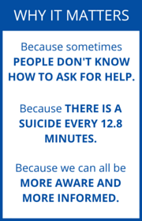
You could be the help that someone needs. Get trained today!
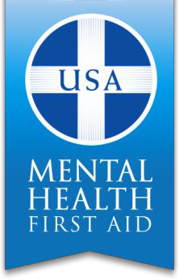
If you are interested in attending a training, hosting a training course for your organization or would like more information visit www.morriscountynj.gov/hs/stigma-free or contact Laurie Becker, Mental Health Administrator at 973-285-6852 or lbecker@co.morris.nj.us

Sample Press Materials

Sample Press Release:

[TOWN] DECLARES MUNICIPALITY A STIGMA-FREE ZONE

One in four adults experiences a diagnosable mental illness every year and many of these individuals do not seek help because of fear of shame or judgment from friends, family and coworkers. On [DATE] [TOWN] made the first steps towards eliminating the stigma associated with mental illness. The elimination of mental health stigma will allow residents to get the resources they need without judgment.

[TOWN] representatives passed a resolution designating the municipality a Stigma-Free Zone in order to create an environment in which residents will feel free to seek treatment for the disease of mental illness without the fear of being stigmatized. [TOWN] joins the County of Morris in declaring a Stigma-Free Zone.

[TOWN] hopes to raise awareness of the disease of mental illness, provide an effective way to reduce the stigma associated with the disease and encourage those who are affected to seek services and feel supported. The establishment of this Stigma-Free Zone will raise awareness of local [TOWN] mental health resources so no one resident needs to feel hopeless or alone. The elimination of stigma will enable residents to ask for help when needed so recovery can begin, hope is inspired and tragedies are avoided.

[TOWN] urges anyone who would like more information on the Stigma-Free Campaign to contact _________ and to help us to eliminate stigma and promote wellness amongst all [TOWN] and Morris County residents.

