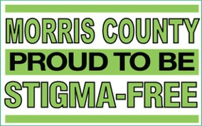

STIGMA‐FREE COMMUNITIES INITIATIVE
FAITH ORGANIZATION TOOLKIT

WRITTEN IN COLLABORATION WITH
THE MENTAL HEALTH ASSOCIATION OF ESSEX AND MORRIS, INC.

The Morris County Stigma‐Free Communities Initiative is a county‐wide program which aims to eradicate the stigma associated with mental illness

and substance use disorders

Morris County Department of Human Services
P.O. Box 900 Morristown, NJ 07963‐0900
Laurie Becker, Mental Health Administrator (973) 285‐6852
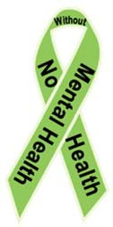

For further information or an electronic version of this toolkit, please visit: www.morriscountynj.gov/hs/stigma‐free

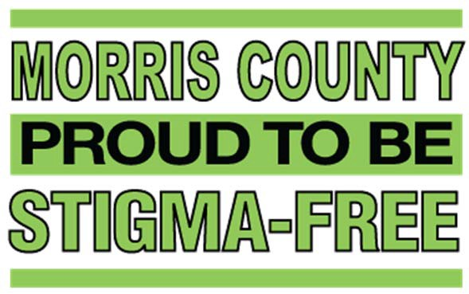

TABLE OF CONTENTS
Introduction……………………………………………………………..………………………………3 Prevalence of Mental Illness………..……………………………………………………………..3 The Stigma‐Free Campaign…………......………………………………………………………….4
Sample Resolution………………………………………………………………………………………5
Stigma‐Free Toolkit…………………………………………………….…………………………….6-9
Forming a Task Force…………………………….…………………………………………6 Stigma Free Action Plan……………..………………………………..……………………7 Mental Health First Aid………………………………………………………….………….8 Sample Press Materials...…………………………………………………………………...9

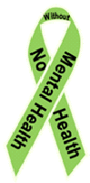
Mental Illness and Stigma

What is a mental illness?
Mental illnesses refer to disorders generally characterized by dysregulation of mood, thought, and/or behavior. Mental illness encompasses a variety of disorders ranging from depression and anxiety to substance
and alcohol use disorder and bipolar disorder. Mental illnesses can affect persons of any age, race, religion or income.

What is stigma?
Stigma is a mark of disgrace which results from the judgment by others. When an individual is labelled by their illness they experience judgment and prejudice.
Stigma brings experiences and feelings of shame, embarrassment, distress, hopelessness and reluctance to seek or accept help. As a result, stigma is the primary reason individuals do not seek help when they experience symptoms of mental illness.

Introduction

The Morris County Stigma‐Free Communities Initiative is a county‐wide program which aims to eradicate the stigma associated with mental illness and substance use disorders. We are dedicated to raising awareness of these illnesses by creating an environment where affected individuals are supported in their efforts to achieve wellness and recovery.

Prevalence of Mental Illness

The World Health Organization ranks mental health conditions, including alcohol and substance use disorders, as the leading cause of disability in the United States and Canada, affecting people of all ages and backgrounds. 1 in 4 adults experience a diagnosable mental disorder in a given year (approximately 61.5 million Americans) and 1 in 17 adults live with a serious mental illness such as schizophrenia or bipolar disorder. Yet more than half will not seek treatment. Why?

The primary reason individuals fail to seek the help they need is due to the stigma associated with the disease of mental illness. Main reasons cited are shame and fear of judgment from friends, family and co‐workers. Such judgment is often rooted in a lack of knowledge or training. It is our goal to disseminate information and foster a stigma‐free environment where people are free from judgment and can get the help they need to recover from disease.
For more information on the disease of mental illness, visit www.nami.org

The Stigma‐Free Communities Initiative

The Stigma‐Free Communities Initiative aims to inspire public interest and open dialogues about the effects of stigma. The County of Morris, several Morris County towns and schools have already passed Stigma‐Free resolutions since the Initiatives inception in Morris County in the spring of 2016.
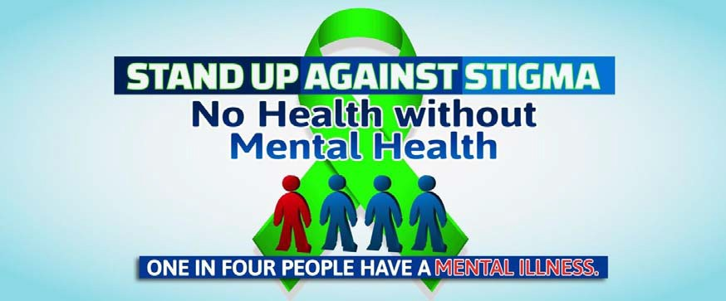

Establishing the Stigma‐Free Communities Initiative will raise awareness of local mental health and recovery resources, increase education on the topics of mental health and addiction, and increase empathy and support so that no resident needs to feel hopeless or alone.

The Stigma‐Free Communities Initiative will encourage residents to:
- Break down barriers to care,
- Be mindful of their mental health,
- Be supportive to those in need and act with empathy, and
- Create a safe environment for people to ask for help when needed.

Substance use disorders and mental illness have the potential to worsen if left untreated and complications arise when individuals do not seek help not only for themselves but for those with whom they share their lives.

It is essential that people engage in care as soon as the need is identified so recovery can begin, hope is inspired and tragedies are avoided. The same need for care and attention often holds true for loved ones, friends and families of those in need of mental health or addiction care.
Who is involved? Everyone is involved. This county‐wide initiative includes all Morris County residents, young and old. From bus drivers to school administrators, business owners to law enforcement, clergy and faith leaders, non-profit organizations and caring individuals, every community member is a key stakeholder. We want to link all stakeholders to training opportunities and awareness events aimed at increasing public knowledge about mental illness and substance use disorders and knowledge of local resources available to Morris County residents.
The following pages include a Stigma‐Free Toolkit for Morris County faith-based organizations interested in joining the Stigma‐Free Initiative. By joining the Stigma‐Free Initiative your organization will be joining a rapidly growing network of municipalities and institutions dedicated to improving the behavioral health of our Morris County community.
SAMPLE: Stigma Free Faith Based Organization Resolution

WHEREAS, the Morris County Board of Chosen Freeholders, along with the Morris County Department of
Human Services, supports the designation of a Stigma‐Free Communities Initiative, and;

WHEREAS, at their April 27, 2016 meeting the Morris County Board of Chosen Freeholders unanimously passed a resolution supporting the designation of Morris County as a Stigma‐Free Community, and;
WHEREAS, Morris County recognizes that one in four Americans has experienced mental illness, including substance use disorders, in a given year according to the National Institute of Mental Health, and;

WHEREAS, mental health problems are more common than cancer and heart disease combined, affecting children and adults, including more than half of our Iraq and Afghanistan Veterans treated at Veteran's Administration hospitals, and;

WHEREAS, given the serious nature of this public health problem, we must continue to reach the millions who need help and their families and community;

WHEREAS, the stigma associated with the disease of mental illness is identified as the primary reason individuals fail to seek the help they need to recover from the disease, and;

WHEREAS, Stigma‐Free Faith Based Organizations aim to inspire public interest and open dialogues about stigma, raise awareness of the disease of mental illness and create a culture wherein people who have the disease of mental illness (and their families) feel supported by their community and feel free to seek treatment for the disease without fear of stigma and;

WHEREAS, promoting awareness that there can be no “health” without mental health will break down barriers and encourage people of all ages to be mindful of their mental health and ask for help when needed, and;

WHEREAS, local resources are available to treat the disease of mental illness so no one person needs to suffer alone or feel hopeless, and;

WHEREAS, establishing Stigma‐Free Faith Based Congregations will raise awareness of resources and encourage congregants to engage in care as soon as the need is identified so recovery can begin, hope is inspired and tragedies are avoided, and;

NOW THEREFORE BE IT RESOLVED that [XXX Faith Based Organization] recognizes the congregation needs and supports the efforts of the County of Morris in designating [XXX Faith Based Organization] as a Stigma‐Free Congregation.

Forming a Stigma‐Free Task Force

Identify Stigma-Free ambassadors:
- A Stigma-Free ambassador is any faith-based organization member who embraces the Stigma-Free Communities Initiative and will help bring your Stigma-Free Congregation to life.
- Stigma-Free ambassadors are involved community members who are connected to the community and understand the specific strengths and weaknesses of your congregation.
Ambassadors do not have to be mental health professionals; they can be individuals who are passionate, interested and energetic. Any proactive congregant can become a Stigma-Free ambassador. An ambassador could be an individual congregant, congregation nurse, secretary, music director, youth director, camp counselor, teacher, study leader, faith organization leader or a faith organization member of any kind. Often times, it may be a person who has personally been affected by a mental illness or substance use disorder, either directly or through a family member.

Form a Stigma-Free Task Force:
Gather a team of dedicated Stigma-Free ambassadors who can help enhance the culture of caring in your congregation, this will be your Stigma-Free Task Force. You can choose to invite task-force members directly, or begin by holding an interest meeting to inform your congregation and other local congregations about the Stigma-Free Initiative, educate and promote awareness, and gather public interest.
Who to invite to join the Stigma-Free Task Force:
- Your designated Faith Leader
- Associate / Assistant Faith Leaders
- Staff of the congregation
- Volunteer leadership / head of ministries
- Youth groups / Women’s groups / Men’s groups
- Congregation Nurses
- Committee, Session or other governing body chair/co-chairs
- Club members
- Athletics Representative
- Other stakeholders and involved congregants
- Board members

Stigma‐Free Action Plan

Below are some ideas to bring your Stigma-Free Congregation to life. Feel free to follow these suggestions and plans and add your own that you think will benefit your congregation. Also, keep in mind that you do not have to do all of these tasks. Any steps you take to decrease stigma are steps in the right direction.
If you are already hosting similar events, you may include them to the Stigma-Free Communities Initiative by simply rebranding the event as “[Event name]: A Stigma-Free Event” and including the welcome message (detailed on the following page) or simply add an activity that educates or increases awareness.

Action Plan suggestions:
- Participate as Stigma Free Ambassadors in any leadership meeting (i.e. Council, Sessions, Committee, any Faith Based Organization internal governance meeting)
- Participate in your Counties Stigma Free Communities Initiative
- Host a stigma free event (i.e. Prayer and awareness event, De-stress Fest, Wellness Forum, Stigma-Free Walk, Recovery Concert)
- Set up a Stigma-Free information booth at other events (i.e. orientation)
- Promote personal stories of wellness and recovery (i.e. guest speakers, publications in bulletins, emails, coffee houses or open mic nights)
- Collaborate with local non-profits and recovery groups to support their efforts.
- Offer Mental Health First Aid training for staff and/or congregants.
- Advocate for inclusion of a Stigma-Free activity in groups or at events.
- Youth outreach through specific programs (i.e. collaborate with local non-profits to help educate)
- Develop a Stigma-Free page on your Website with local mental health resources and information or add the Morris County Stigma-Free Communities Initiative link to an already existing website.
- Promote the Stigma-Free initiative through the your organizations newspaper, bulletin or other mailing (i.e. provide an announcement about the Stigma-Free Initiative or a Stigma-Free Event, provide a monthly Stigma-Free update)
- Promote your involvement through press release to local newspapers
- Distribute Stigma-Free promotional materials (i.e. Lawn signs, decals, pens)
Example Stigma-Free Welcome Message:
“Hello, and welcome to the [insert event name]. In line with our new Stigma-Free Initiative, this event will be a Stigma-Free event. Stigma is a mark of disgrace which results from judgment by others. Stigma brings experiences and feelings of shame, embarrassment, distress, hopelessness and reluctance to seek or accept help. As part of a county-wide initiative, [insert name here] is acting to disseminate information and foster a stigma-free environment where people are free from judgment and can get the help they need to recover from mental illness and substance use disorders. We’d like to open this event by reminding you that everyone has the power to break through stigma. We encourage you to support one another, seek the services you need, and do not judge. Together we can decrease stigma to create a culture of caring in our congregation and to be carried out into the community. Please contact [insert Stigma Free Task Force contact person] for more information.”

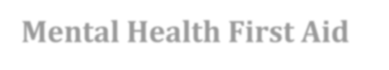
Mental Health First Aid

What is Mental Health First Aid?

Mental Health First Aid is a public education program that introduces participants to risk factors and warning signs of mental health problems, builds understanding of their impact and overviews appropriate supports. This 8‐hour course uses role‐playing and simulations to demonstrate how to offer initial help in a mental health crisis and connect people to the appropriate professional, peer, social and self‐help care. The program also teaches common risk factors and warning signs of specific illnesses like anxiety, depression, substance use, bipolar disorder, eating disorders and schizophrenia.

What do you learn?
Just as CPR helps you assist an individual having a heart attack, Mental Health First Aid helps you assist someone experiencing a mental health or substance use‐related crisis. In the Mental Health First Aid course, you learn risk factors and warning signs for mental health and addiction concerns, strategies for how to help someone in both crisis and non‐crisis situations, and where to turn for help.

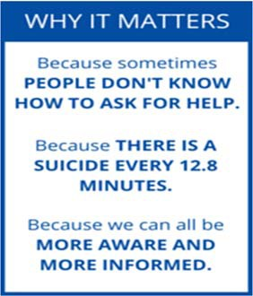

You could be the help that someone needs. Get trained today!
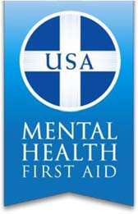
If you are interested in attending a training, hosting a training course for your organization or would like more information visit www.morriscountynj.gov/hs/stigma‐free or contact Laurie Becker, Mental Health Administrator at 973‐285‐6852 or lbecker@co.morris.nj.us

Sample Press Release:
Sample Press Materials

[NAME OF FAITH BASED ORGANIZATION]
DECLARES TO BE A STIGMA‐FREE ZONE

One in four adults experiences a diagnosable mental illness every year and many of these individuals do not seek help because of fear of shame or judgment from friends, family and coworkers. On [DATE] [FAITH BASED ORGANIZATION] has made steps towards eliminating the stigma associated with mental illness and addiction. The elimination of mental health stigma will allow people to get the resources they need without judgment.

[FAITH BASED ORGANIZATION] joins the County of Morris in an initiative to make their congregation a Stigma‐Free Zone in order to create an environment in which people will feel safe to seek treatment for the disease of mental illness or addiction without the fear of being stigmatized.

[FAITH BASED ORGANIZATION] hopes to raise awareness of the disease of mental illness, provide an effective way to reduce the stigma associated with the disease and encourage those who are affected to seek services and feel supported. The establishment of this Stigma‐Free Zone will raise awareness of local mental health resources so no person feels hopeless or alone. The elimination of stigma will enable congregants to ask for help when needed so recovery can begin, hope is inspired and tragedies are avoided.

[FAITH BASED ORGANIZATION] urges anyone who would like more information on the Stigma‐Free Campaign to contact and to help to eliminate stigma and promote wellness amongst all [FAITH BASED ORGANIZATION] congregants and Morris County residents.

